
Safety Bay Senior High School
Chemistry Unit 1

Test #4:
Energy Effects & Reaction Rates

NAME: ______________________________________

DATE: ______________________________________

Section | Mark
Multiple Choice | / 16
Short Answer | / 44
Total | / 60

MULTIPLE CHOICE 16 marks

- Which of the following reactions is endothermic?

  - Burning magnesium metal [releases heat]
  - Condensation of water [forming bonds = exothermic]
  - Melting candle wax [breaking of bonds = endothermic]
  - Adding concentrated acid to water [releases heat]

- A small beaker contains ammonium thiocyanate and barium hydroxide stands in a puddle of water on a bench. As the reaction proceeds the puddle of water around the beaker freezes, cementing it to the bench top. This indicates that the reaction is:

  - Endothermic, because heat is absorbed from the surroundings into the system
  - Exothermic, because heat is absorbed from the surroundings into the system
  - Endothermic, because heat is absorbed from the system into the surroundings
  - Exothermic, because heat is absorbed from the system into the surroundings

- Which option from the table below matches the following energy profile diagram?
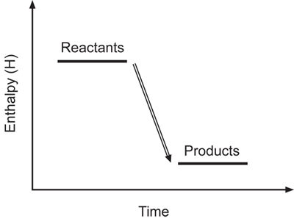
 | Forwards reaction | Reverse reaction
(a) | Endothermic | Endothermic
(b) | Endothermic | Exothermic
(c) | Exothermic | Endothermic
(d) | Exothermic | Exothermic

- In a series of experiments, 0.0100 g samples of magnesium were added separately to 20.0 mL volumes of hydrochloric acid.

Experiment number | Form of magnesium used | Concentration of acid | Temperature of acid (ºC)
1 | Ribbon | Dilute | 90
2 | Ribbon | Concentrated | 20
3 | Powder | Dilute | 20
4 | Powder | Concentrated | 90

In which of the experiments would the magnesium be expected to take the shortest time to react completely with the acid?

  - Experiment #1
  - Experiment #2
  - Experiment #3
  - Experiment #4

- Consider the following equations:
I. C₄H₁₀(l) + 6 O₂(g) 4 CO₂(g) + 5 H₂O(l) ΔH = -2727 kJ mol⁻¹
II. 6CO₂(g) + 6H₂O(l) C₆H₁₂O₆(s) + 6 O₂(g) ΔH =+2816 kJ mol⁻¹
III. CO(g) + ½ O₂(g) CO₂(g) + 283 kJ
IV. C₃H₈(g) + 104 kJ 3 C(s) + 4 H₂(g)

Which of the above reactions are exothermic?

  - Experiment I and III
  - Experiment I and IV
  - Experiment II and III
  - Experiment II and IV

- The neutralisation reaction between nitric acid and potassium hydroxide may be represented as:
HNO₃(aq) + KOH(aq) KNO₃(aq) + H₂O(l) + 57 kJ

If beakers with nitric acid and potassium hydroxide were mixed at room temperature then you would expect the temperature of the resulting solution to:
  - Increase in temperature and then stay constant
  - Increase in temperature and then slowly decrease
  - Decrease in temperature and then return to room temperature
  - Decrease in temperature and then stay constant

- Copper normally does not react with acids, but can react with concentrated nitric acid according to the following equation:

Cu(s) + 4HNO₃(aq) Cu(NO₃)₂(aq) + 2NO₂(g) + 2H₂O(ℓ)

Which of the following will not increase the rate of reaction?

  - Decreasing the size of the solid copper particles
  - Increasing the temperature of HNO₃ by 20 °C
  - Increasing the concentration of HNO₃
  - Increasing the volume of HNO₃ solution used

- In the above reaction involving copper and nitric acid, the number of successful collisions is a small fraction of the total number of collisions.

The major reason for this is that:

  - The reaction is exothermic which makes it unlikely to occur
  - Some reactant particles have too much kinetic energy
  - The kinetic energy of the particles is reduced when they collide with the container’s walls
  - Not all reactant particles have the minimum kinetic energy required to initiate the reaction

- The following reaction is used in some industries to produce hydrogen.

CO(g) + H₂O(g) CO₂(g) + H₂(g) ΔH = -41 kJ mol⁻¹.

In trials, the reaction is carried out with and without a catalyst in a sealed container. All other conditions remain unchanged. The change in hydrogen concentration with time between an uncatalysed and catalysed reaction can be represented by a graph.

Which graph is correct? C

- Consider the following energy profile diagram for a reaction represented by the equation
X + Y Z.
Which one of the following provides the correct values of the activation energy and enthalpy for the reaction X + Y Z?

 | Activation energy (kJ mol⁻¹) | Enthalpy (kJ mol⁻¹)
(a) | +75 | +100
(b) | +100 | +175
(c) | +175 | +100
(d) | +200 | -125
Questions 11-12 refer to the following information…

An experiment was performed to measure the amount of oxygen gas evolved at ten second intervals, when 40 mL of hydrogen peroxide was allowed to decompose according to the equation:

$$2H_{2}O_{2}\left(l\right)\underset{→}{{MnO}_{2}}2H_{2}O\left(l\right)+O_{2}(g)$$

The reaction was carried out at 20 ºC and 0.5 g of manganese dioxide added at the start of the experiment. The results are shown in the graph below.

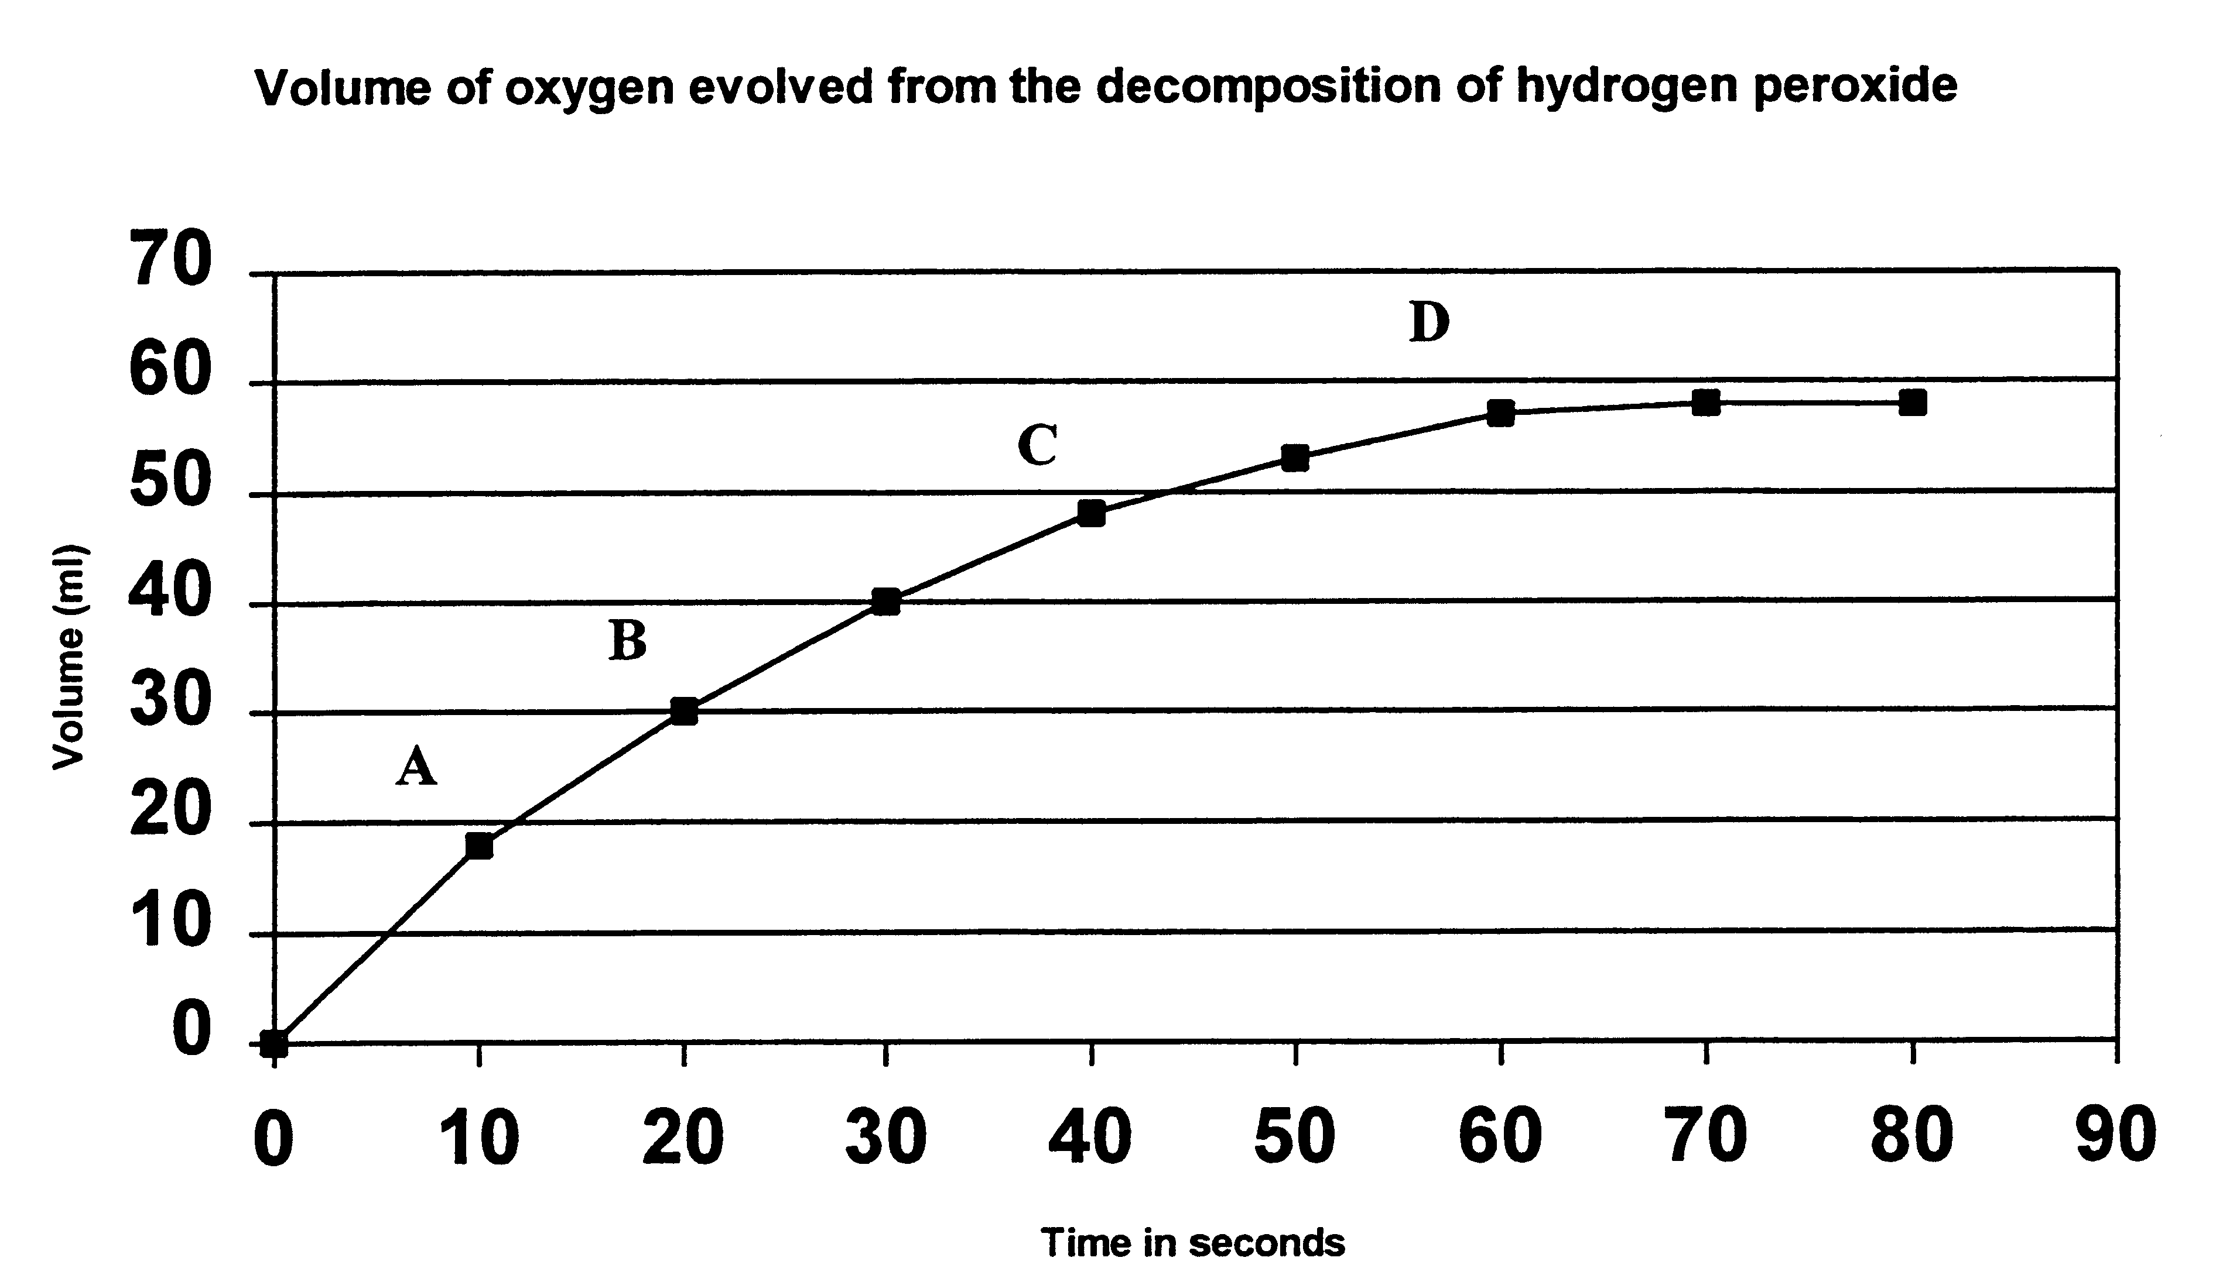

- Which of the following options has the greatest reaction rate?

  - The average rate from C to D
  - The average rate from A to C
  - The average rate from B to C
  - The instantaneous rate at D

- Only a very small amount of MnO₂ is added to this reaction, but this amount is sufficient to increase the reaction rate. What is the best explanation for this?

  - A small mass of MnO₂ corresponds to a large number of moles due to its large molar mass
  - The MnO₂ is only needed to provide particles with the initial energy needed to kick-start the reaction
  - The H₂O₂ used in this reaction is very dilute so only a small concentration of MnO₂ is required
  - The MnO₂ is regenerated as a part of the reaction so there is always some MnO₂ available
Questions 13-15 refer to the following information…

H₂ + I₂
2HI
A
B
C
Potential energy

- For the reaction H₂(g) + I₂(g) 2HI(g), which of the following is true?

  - It is an endothermic reaction. ΔH = A
  - It is an exothermic reaction. ΔH = C
  - It is an exothermic reaction. ΔH = (A-B)
  - It is an endothermic reaction. ΔH = (B-A)

- The activation energy for the reverse reaction would be given as…

  - A
  - B
  - C
  - A – B

- The introduction of a catalyst to the system would alter:

  - C only
  - A only
  - A and B only
  - A, B and (A-B) only

- In an investigation, the volume of a gas produced during a reaction was measured every five seconds and plotted on a graph until the reaction stopped. This was repeated for the same reaction using different concentrations of acid. The aim of the investigation was to determine:

  - The rate of this reaction
  - The effect of time on the rate of this reaction
  - The effect of gas volume on the rate of this reaction
  - The effect of concentration on the rate of this reaction
SHORT ANSWER 44 marks

- (7 marks)

The decomposition of ammonia is represented by the following unbalanced equation:

____ NH₃(g) ___ N₂(g) + ___ H₂ ΔH = +92.4 kJ mol⁻¹

- Balance the above equation by adding coefficients before each chemical species. (1 mark)
Answer | Marks
2 NH₃ N₂ + 3 H₂ | 1 mark
Total marks: | 1mark

- The activation energy for the uncatalysed reaction is 335 kJ mol⁻¹.
The activation energy for the reaction when tungsten is used as a catalyst is 163 kJ mol⁻¹.

On the grid provided below, draw a labelled energy profile diagram for the uncatalysed and tungsten-catalysed reactions. If you make a mistake, cross out this attempt and use the spare grid on the last page. (4 marks)

Answer | Marks
Endothermic reaction shape (products > reactants) | 1 mark
Delta H is correct value (~92 kJ/mol) | 1 mark
Uncatalysed pathway is labelled and has Ea of 335 kJ/mol | 1 mark
Catalysed pathway is labelled and has Ea of 163 kJ/mol | 1 mark
Total marks: | 4 marks

- When osmium is used as a catalyst, the activation energy is 197 kJ mol⁻¹.

Which catalyst – osmium or tungsten – will cause ammonia to decompose at a faster rate? Justify your answer in terms of the chemical principles you have studied this year. (2 marks)

Answer | Marks
Tungsten has a faster reaction rate due to having less activation energy… | 1 mark
… which means a greater percentage/proportion of collisions lead to successful reactions | 1 mark
Total marks: | 2 marks

- (2 marks)

According to collision theory, what two factors determine whether a collision between two particles will lead to a successful chemical reaction?

Answer | Marks
Orientation | 1 mark
Energy | 1 mark
Total marks: | 2 marks

- (3 marks)

List three ways in which you can increase the frequency of collisions between particles in a reaction.

Answer | Marks
- Increase concentration  - Increase temperature  - Increase surface area  - Increase gas pressure | 1 mark each
Total marks: | 3 marks

- (5 marks)

The following energy profile diagram shows the reaction between H₂ and F₂ to form HF.

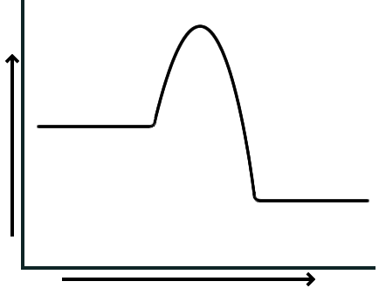
2 HF
H₂ + F₂
Reaction progress
Enthalpy

- Which bonds are broken and which bonds are formed during this reaction? (3 marks)

Answer | Marks
Covalent bonds between H and H are broken | 1 mark
Covalent bonds between F and F are broken | 1 mark
Covalent bonds between H and F are formed | 1 mark
Total marks: | 3 marks

- Compare the relative strengths of the bonds discussed in part (a) using information from the energy profile diagram. Explain how you came to your answer. (2 marks)

Example answers:
The activation energy shows the energy required to break bonds. The forwards reaction has less activation energy than the reverse reaction. This indicates that the bonds in the reactants are weaker than the products.

Or…

Bond forming releases energy whereas bond breaking consumes energy. We can see from the diagram that more energy is released forming bonds than breaking bonds, indicating that the H-F bonds are stronger than the H-H and F-F bonds.

Answer | Marks
Shows understanding that breaking bonds requires energy / forming bonds releases energy | 1 mark
Uses information in diagram to successfully explain that the bonds in the products are stronger than the bonds in the reactants. | 1 mark
Total marks: | 2 marks

- (7 marks)

The reaction between hydrochloric acid and magnesium can be quite vigorous. List three different ways the reaction rate between these two substances could be DECREASED, and explain using collision theory how each method could decrease the reaction rate.

Answer | Marks
Decrease the concentration.  Less frequent collisions between reactant particles, therefore slower rate | 1 mark  1 mark
Decrease the surface area (e.g. chunk of Mg instead of ribbon)  Less frequent collisions between reactant particles, therefore slower rate | 1 mark  1 mark
Decrease temperature  Less particles have sufficient activation energy to react  Particles move slower so less frequent collisions | 1 mark  1 mark  1 mark
Total marks: | 2 marks

- (7 marks)

Hydrogen gas was generated by the reaction of hydrochloric acid and magnesium under two sets of conditions. The mass of hydrogen gas was measured every 5 seconds over a period of one minute and the results for each experiment (Reaction A and Reaction B) are graphed below.

Reaction B
Reaction A

- After how many seconds do reaction A and B finish? (1 mark)

Answer | Marks
A: 25 seconds  B: 50 seconds | 1 mark
Total marks: | 1 mark

- Calculate the reaction rate between 10 seconds and 20 seconds for reaction B. Include appropriate units in your answer. (3 marks)

Answer | Marks
$$rate=\frac{rise}{run}=\frac{55-31}{20-10}=2.4 g s^{-1}$$ | 1-2 marks
Includes correct units | 1 mark
Total marks: | 1 mark

- Account for the change in shape of the graph for Reaction A as the reaction progresses.
(3 marks)

Answer | Marks
Over time reaction slows down… | 1 mark
…due to decreasing concentration of reactants. | 1 mark
No change after 25 seconds because one of the reactants has run out | 1 mark
Total marks: | 3 marks

- (4 marks)

Consider the following combustion reaction: CH₄ + 2O₂ CO₂ + 2H₂O + 889 kJ

- Write the value for the change in enthalpy, including the appropriate sign. (1 mark)

Answer | Marks
ΔH = -889 kJ (or kJ/mol) | 1 mark
Total marks: | 1 mark

- Calculate the energy released when 80 g of methane is burnt according to the equation above. Answer to three significant figures and give the correct units for your answer.
(3 marks)

Answer | Marks
$$n\left({CH}_{4}\right)=\frac{m}{M}=\frac{80}{16.042}=4.99 mol$$ | 1 mark
Heat released = 4.99 mol x 889 kJ/mol = 4430 kJ | 1 mark
Goes to 3 significant figures and includes correct units, e.g.  - 4430 kJ, OR  - 4.43 x 10³ kJ, OR  - 4.43 x 10⁶ J | 1 mark
Total marks: | 3 marks
- (9 marks)

Two students placed a large piece of zinc into a conical flask containing 100 mL of 1.0 mol L⁻¹ hydrochloric acid solution at 20 °C.

Zn(s) + 2 HCℓ(aq) ZnCℓ₂(aq) + H₂(g) ΔH < 0

They then recorded the mass of the conical flask and its contents over twenty minutes. The results they obtained for the first two minutes were:

Time (s) | Mass of flask and contents (g)
0 | 270.30
30 | 270.20
60 | 270.11
90 | 270.01
120 | 269.95
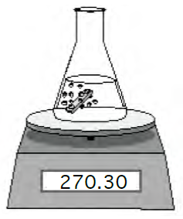
Experiment 1:

- Use the data in the table above to calculate the average rate of formation of hydrogen gas, in mol min⁻¹, over the first two minutes. (3 marks)

Answer | Marks
Mass of H₂ = 0.35 g | 1 mark
n(H₂) = m/M = 0.35 / 2.016 = 0.174 mol | 1 mark
Rate = moles/time = 0.174/2 = 0.0868 mol min⁻¹ | 1 mark
Total marks: | 3 marks

- The graph below shows the loss of mass of the flask and contents over the entire twenty minutes. (2 marks)
Experiment 3
Experiment 2

The students modified this experiment, in each case using the same size piece of zinc as used in Experiment 1.

Experiment 2: 100 mL of 0.50 mol L⁻¹ hydrochloric acid
Experiment 3: 100 mL of 1.0 mol L⁻¹ HCl with a few drops of CuSO₄ catalyst

Answer | Marks
Each plotted line as shown above. Must be labelled. | 1 mark each
Total marks: | 2 marks
- The students decided to repeat Experiment 1, but this time using 100 mL of 1.0 mol L⁻¹ hydrochloric acid solution at 50 °C.

Use collision theory and graphs of the kinetic energy distributions for the reacting particles to compare the reaction at 50 °C with that at 20 °C. (4 marks)

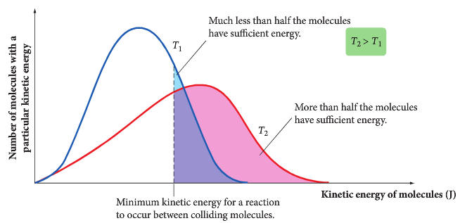

Answer | Marks
Graph:  - Shows distributions at two temperatures  - Shows E_{a} on graph | 1 mark  1 mark
Explanation:  - A greater portion of particles at 50 °C has energy > E_{a}, so a greater proportion of collisions lead to successful reactions  - Particles are moving faster at 50 °C so there would also be more frequent collisions | 1 mark  1 mark
Total marks: | 4 marks

